INTRODUCTION

The ATM, or Automatic Teller Machine, is a machine that dispenses cash to bank account holders. ATMs are used as a convenient way to check your bank account balances, get cash, make account transfers, and make a deposit into your accounts.
To use an ATM, a bank card is required. The ATM card has a magnetic strip or a chip that communicates with the ATM machine (here user has to enter the card number). Along with an ATM card, you have a password, card a pin number. You should keep your pin number secret, and never share it with anyone. Also, if you ever lose your ATM card, you should report it to your bank immediately. To begin use of an ATM, you normally will insert your card and enter your pin number.
Using an ATM is not always free. Many banks charge a small fee to do an ATM transaction or use their service. Sometimes it is free to use your own bank's ATM rather than an ATM owned by another bank. You should check with your bank to see what service fees there may be, if any.
ATM machines are located in many banks, grocery stores, etc. and may be located inside and outside of buildings. Be aware of the location and surroundings and try to make sure it is safe to use before using. If you feel uncomfortable, cancel the transaction and go to a different ATM.
When you are done using the ATM, be sure to get your bank card, your receipt, and any money you may have withdrawn.

ATM simulation is a java project that functions similarly to the normal atm. As a user, you can simply deposit, withdraw and check the account balance. Also, you can change your password.

This report attempts to understand the design of an Automated Teller Machine (ATM) system, a device used by bank customers to process account transactions. Typically, a user inserts into the ATM a special plastic card that is encoded with information on a magnetic strip. The strip contains an identification code that is transmitted to the bank's central computer by modem. To prevent unauthorized transactions, a personal identification number (PIN) most also be entered by the user using a keypad. The computer then permits the ATM to complete the transaction; most machines can dispense cash, accept deposits, transfer funds, and provide information on account balances.
SOFTWARE REQUIREMENTS SPECIFICATION
The system should be able to perform the following operations:
- Login using Card Number and PIN
- New User Signup and generation of new Card number and PIN
- Cash Deposit using mobile number and PIN
- Cash Withdraw using mobile number and PIN
- Fast Cash using mobile number and PIN
- PIN Change
- View account balance
Hardware Requirements:
- Keyboard
- Mouse
Software Requirements:
- WampServer to provide MySQL.
- NetBeans IDE for Java
- Java JDBC connector (inbuilt in NetBeans IDE).

State Diagram
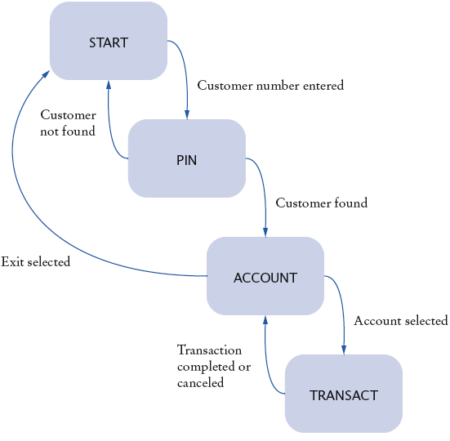
ER DIAGRAM
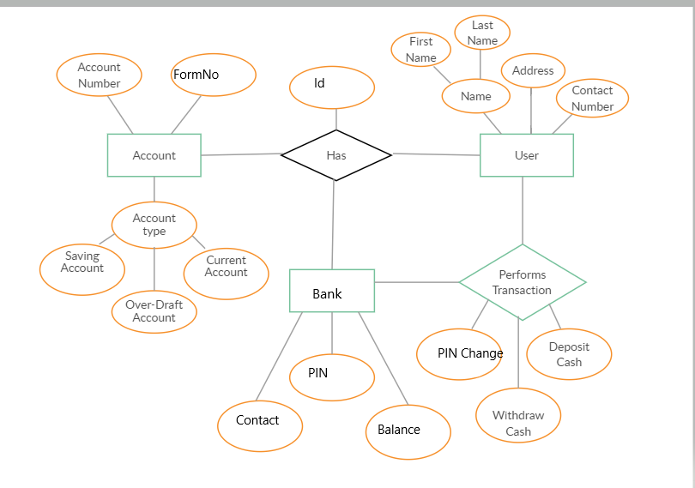

IMPLEMENTATION

Program: -
Class conn.java
package atmsimulationsystem;
import java.sql.*;
public class conn{
Connection c;
Statement s;
public conn(){
try{ Class.forName("com.mysql.jdbc.Driver");
c =DriverManager.getConnection("jdbc:mysql:///project3","root","");
s =c.createStatement();
}catch(Exception e){
System.out.println(e);}}}

Login.java

package atmsimulationsystem;
import java.awt.*;
import java.awt.event.*;
import javax.swing.*;
import java.sql.*;
public class Login extends JFrame implements ActionListener{
JLabel l1,l2,l3;
JTextField tf1;
JPasswordField pf2;
JButton b1,b2,b3;
Login(){
//Move the text to the center
setFont(new Font("System", Font.BOLD, 22));
Font f = getFont();
FontMetrics fm = getFontMetrics(f);
int x = fm.stringWidth("AUTOMATED TELLER MACHINE");
int y = fm.stringWidth(" ");
int z = getWidth() - x;
int w = z/y;
String pad ="";
//for (int i=0; i!=w; i++) pad +=" ";
pad = String.format("%"+w+"s", pad);
setTitle(pad+"AUTOMATED TELLER MACHINE");
l1 = new JLabel("WELCOME TO ATM");
l1.setFont(new Font("Osward", Font.BOLD, 38));
l2 = new JLabel("Card No:");
l2.setFont(new Font("Raleway", Font.BOLD, 28));
l3 = new JLabel("PIN:");
l3.setFont(new Font("Raleway", Font.BOLD, 28));
tf1 = new JTextField(15);
pf2 = new JPasswordField(15);
b1 = new JButton("SIGN IN");
b1.setBackground(Color.BLACK);
b1.setForeground(Color.WHITE);
b2 = new JButton("CLEAR");
b2.setBackground(Color.BLACK);
b2.setForeground(Color.WHITE);
b3 = new JButton("SIGN UP");
b3.setBackground(Color.BLACK);
b3.setForeground(Color.WHITE);
setLayout(null);
l1.setBounds(175,50,450,200);
add(l1);
l2.setBounds(125,150,375,200);
add(l2);
l3.setBounds(125,225,375,200);
add(l3);
tf1.setFont(new Font("Arial", Font.BOLD, 14));
tf1.setBounds(300,235,230,30);
add(tf1);
pf2.setFont(new Font("Arial", Font.BOLD, 14));
pf2.setBounds(300,310,230,30);
add(pf2);
b1.setFont(new Font("Arial", Font.BOLD, 14));
b1.setBounds(300,400,100,30);
add(b1);
b2.setFont(new Font("Arial", Font.BOLD, 14));
b2.setBounds(430,400,100,30);
add(b2);
b3.setFont(new Font("Arial", Font.BOLD, 14));
b3.setBounds(300,450,230,30);
add(b3);b1.addActionListener(this);
b2.addActionListener(this);
b3.addActionListener(this);
getContentPane().setBackground(Color.WHITE);
setSize(750,700);
setLocation(300,5);
setVisible(true); }
public void actionPerformed(ActionEvent ae){
try{
conn c1 = new conn();
String a = tf1.getText();
String b = pf2.getText();
String q = "select * from signup3 where cardno = '"+a+"' and pin = '"+b+"'";
ResultSet rs = c1.s.executeQuery(q);

if(ae.getSource()==b1){
if(rs.next()){
new Transcations().setVisible(true);
setVisible(false);

}else{
JOptionPane.showMessageDialog(null, "Incorrect Card Number or Password");

}
}else if(ae.getSource()==b2){
tf1.setText("");
pf2.setText("");
}else if(ae.getSource()==b3){
JOptionPane.showMessageDialog(null, "PLEASE NOTE YOUR FORM NUMBER ");
new Signup().setVisible(true);
setVisible(false);
}
}catch(Exception e){
e.printStackTrace();
System.out.println("error: "+e);}}
public static void main(String[] args){
new Login().setVisible(true);}}
Signup.java

package atmsimulationsystem;
import java.awt.*;
import java.awt.event.*;
import javax.swing.*;
import java.sql.*;
import java.util.*;
public class Signup extends JFrame implements ActionListener{

JLabel l1,l2,l3,l4,l5,l6,l7,l8,l9,l10,l11,l12,l13,l14,l15;
JTextField t1,t2,t3,t4,t5,t6,t7;
JRadioButton r1,r2,r3,r4,r5;
JButton b;
JComboBox c1,c2,c3;
Random ran = new Random();
long first4 = (ran.nextLong() % 9000L) + 1000L;
long first = Math.abs(first4);

Signup(){
//Move the text to the center
setFont(new Font("System", Font.BOLD, 22));
Font f = getFont();
FontMetrics fm = getFontMetrics(f);
int x = fm.stringWidth("NEW ACCOUNT APPLICATION FORM");
int y = fm.stringWidth(" ");
int z = getWidth() - x;
int w = z/y;
String pad ="";
//for (int i=0; i!=w; i++) pad +=" ";
pad = String.format("%"+w+"s", pad);
setTitle(pad+"NEW ACCOUNT APPLICATION FORM");
l1 = new JLabel("APPLICATION FORM NO. "+first);
l1.setFont(new Font("Raleway", Font.BOLD, 38));

l2 = new JLabel("Page 1: Personal Details");
l2.setFont(new Font("Raleway", Font.BOLD, 22));

l3 = new JLabel("Name:");
l3.setFont(new Font("Raleway", Font.BOLD, 20));

l4 = new JLabel("Father's Name:");
l4.setFont(new Font("Raleway", Font.BOLD, 20));

l5 = new JLabel("Date of Birth:");
l5.setFont(new Font("Raleway", Font.BOLD, 20));

l6 = new JLabel("Gender:");
l6.setFont(new Font("Raleway", Font.BOLD, 20));

l7 = new JLabel("Email Address:");
l7.setFont(new Font("Raleway", Font.BOLD, 20));

l8 = new JLabel("Marital Status:");
l8.setFont(new Font("Raleway", Font.BOLD, 20));

l9 = new JLabel("Address:");
l9.setFont(new Font("Raleway", Font.BOLD, 20));

l10 = new JLabel("City:");
l10.setFont(new Font("Raleway", Font.BOLD, 20));

l11 = new JLabel("Pin Code:");
l11.setFont(new Font("Raleway", Font.BOLD, 20));

l12 = new JLabel("State:");
l12.setFont(new Font("Raleway", Font.BOLD, 20));

l13 = new JLabel("Date");
l13.setFont(new Font("Raleway", Font.BOLD, 14));

l14 = new JLabel("Month");
l14.setFont(new Font("Raleway", Font.BOLD, 14));

l15 = new JLabel("Year");
l15.setFont(new Font("Raleway", Font.BOLD, 14));

t1 = new JTextField();
t1.setFont(new Font("Raleway", Font.BOLD, 14));

t2 = new JTextField();
t2.setFont(new Font("Raleway", Font.BOLD, 14));

t3 = new JTextField();
t3.setFont(new Font("Raleway", Font.BOLD, 14));

t4 = new JTextField();
t4.setFont(new Font("Raleway", Font.BOLD, 14));

t5 = new JTextField();
t5.setFont(new Font("Raleway", Font.BOLD, 14));

t6 = new JTextField();
t6.setFont(new Font("Raleway", Font.BOLD, 14));

t7 = new JTextField();
t7.setFont(new Font("Raleway", Font.BOLD, 14));
b = new JButton("Next");
b.setFont(new Font("Raleway", Font.BOLD, 14));
b.setBackground(Color.BLACK);
b.setForeground(Color.WHITE);

r1 = new JRadioButton("Male");
r1.setFont(new Font("Raleway", Font.BOLD, 14));
r1.setBackground(Color.WHITE);

r2 = new JRadioButton("Female");
r2.setFont(new Font("Raleway", Font.BOLD, 14));
r2.setBackground(Color.WHITE);

r3 = new JRadioButton("Married");
r3.setFont(new Font("Raleway", Font.BOLD, 14));
r3.setBackground(Color.WHITE);

r4 = new JRadioButton("Unmarried");
r4.setFont(new Font("Raleway", Font.BOLD, 14));
r4.setBackground(Color.WHITE);

r5 = new JRadioButton("Other");
r5.setFont(new Font("Raleway", Font.BOLD, 14));
r5.setBackground(Color.WHITE);
String date[] = {"1","2","3","4","5","6","7","8","9"};
c1 = new JComboBox(date);
c1.setBackground(Color.WHITE);

String month[] = {"January","February","March","April","May","June","July","August","September","October","November","December"};
c2 = new JComboBox(month);
c2.setBackground(Color.WHITE);

String year[] = {"1990","1991","1992","1993","1994","1995","1996","1997","1998","1999","2000","2001","2002"};
c3 = new JComboBox(year);
c3.setBackground(Color.WHITE);

setLayout(null);
l1.setBounds(140,20,600,40);
add(l1);

l2.setBounds(290,70,600,30);
add(l2);

l3.setBounds(100,140,100,30);
add(l3);

t1.setBounds(300,140,400,30);
add(t1);

l4.setBounds(100,190,200,30);
add(l4);

t2.setBounds(300,190,400,30);
add(t2);

l5.setBounds(100,240,200,30);
add(l5);

l13.setBounds(300,240,40,30);
add(l13);

c1.setBounds(340,240,60,30);
add(c1);

l14.setBounds(410,240,50,30);
add(l14);

c2.setBounds(460,240,100,30);
add(c2);

l15.setBounds(570,240,40,30);
add(l15);

c3.setBounds(610,240,90,30);
add(c3);

l6.setBounds(100,290,200,30);
add(l6);

r1.setBounds(300,290,60,30);
add(r1);

r2.setBounds(450,290,90,30);
add(r2);

l7.setBounds(100,340,200,30);
add(l7);

t3.setBounds(300,340,400,30);
add(t3);

l8.setBounds(100,390,200,30);
add(l8);

r3.setBounds(300,390,100,30);
add(r3);

r4.setBounds(450,390,100,30);
add(r4);

r5.setBounds(635,390,100,30);
add(r5);

l9.setBounds(100,440,200,30);
add(l9);

t4.setBounds(300,440,400,30);
add(t4);

l10.setBounds(100,490,200,30);
add(l10);

t5.setBounds(300,490,400,30);
add(t5);

l11.setBounds(100,540,200,30);
add(l11);

t6.setBounds(300,540,400,30);
add(t6);

l12.setBounds(100,590,200,30);
add(l12);

t7.setBounds(300,590,400,30);
add(t7);

b.setBounds(620,660,80,30);
add(b);

b.addActionListener(this);

getContentPane().setBackground(Color.WHITE);

setSize(850,750);
setLocation(300,9);
setVisible(true);
}

public void actionPerformed(ActionEvent ae){

String a = t1.getText();
String b = t2.getText();

String ac = (String)c1.getSelectedItem();
String bc = (String)c2.getSelectedItem();
String cc = (String)c3.getSelectedItem();

String d = null;
if(r1.isSelected()){
d = "Male";
}
else if(r2.isSelected()){
d = "Female";
}

String e = t3.getText();
String f = null;
if(r3.isSelected()){
f = "Married";
}else if(r4.isSelected()){
f = "Unmarried";
}else if(r5.isSelected()){
f = "Other";
}

String g = t4.getText();
String h = t5.getText();
String i = t6.getText();
String j = t7.getText();

try{

if(t6.getText().equals("") || t3.getText().equals("") || t1.getText().equals("") || t7.getText().equals("") ){
JOptionPane.showMessageDialog(null, "Fill all the required fields");
}else{
EmailValidator emailValidator = new EmailValidator();
if(!emailValidator.validate(t3.getText().trim())) {
JOptionPane.showMessageDialog(null, "Invalid Email ID!");
}else{
conn c1 = new conn();

String q1 = "insert into signup values('"+a+"','"+b+"','"+ac+"','"+bc+"','"+cc+"','"+d+"','"+e+"','"+f+"','"+g+"','"+h+"','"+i+"','"+j+"','"+first+"')";
c1.s.executeUpdate(q1);

new Signup2().setVisible(true);
setVisible(false);
}
}

}catch(Exception ex){

ex.printStackTrace();
}

}

public static void main(String[] args){
new Signup().setVisible(true);
}
}
Signup2.java

package atmsimulationsystem;

import java.awt.*;
import java.awt.event.*;
import javax.swing.*;
import java.sql.*;

public class Signup2 extends JFrame implements ActionListener{

JLabel l1,l2,l3,l4,l5,l6,l7,l8,l9,l10,l11,l12;
JButton b;
JRadioButton r1,r2,r3,r4;
JTextField t1,t2,t3;
JComboBox c1,c2,c3,c4,c5;
Signup2(){

setFont(new Font("System", Font.BOLD, 22));
Font f = getFont();
FontMetrics fm = getFontMetrics(f);
int x = fm.stringWidth("NEW ACCOUNT APPLICATION FORM - PAGE 2");
int y = fm.stringWidth(" ");
int z = getWidth()/2 - (x/2);
int w = z/y;
String pad ="";
//for (int i=0; i!=w; i++) pad +=" ";
pad = String.format("%"+w+"s", pad);
setTitle(pad+"NEW ACCOUNT APPLICATION FORM - PAGE 2");

l1 = new JLabel("Page 2: Additonal Details");
l1.setFont(new Font("Raleway", Font.BOLD, 22));

l2 = new JLabel("Religion:");
l2.setFont(new Font("Raleway", Font.BOLD, 18));

l3 = new JLabel("Category:");
l3.setFont(new Font("Raleway", Font.BOLD, 18));

l4 = new JLabel("Income:");
l4.setFont(new Font("Raleway", Font.BOLD, 18));

l5 = new JLabel("Educational");
l5.setFont(new Font("Raleway", Font.BOLD, 18));

l11 = new JLabel("Qualification:");
l11.setFont(new Font("Raleway", Font.BOLD, 18));

l6 = new JLabel("Occupation:");
l6.setFont(new Font("Raleway", Font.BOLD, 18));

l7 = new JLabel("PAN Number:");
l7.setFont(new Font("Raleway", Font.BOLD, 18));

l8 = new JLabel("Aadhar Number:");
l8.setFont(new Font("Raleway", Font.BOLD, 18));

l9 = new JLabel("Senior Citizen:");
l9.setFont(new Font("Raleway", Font.BOLD, 18));

l10 = new JLabel("Existing Account:");
l10.setFont(new Font("Raleway", Font.BOLD, 18));

l12 = new JLabel("Form No:");
l12.setFont(new Font("Raleway", Font.BOLD, 13));
b = new JButton("Next");
b.setFont(new Font("Raleway", Font.BOLD, 14));
b.setBackground(Color.BLACK);
b.setForeground(Color.WHITE);
t1 = new JTextField();
t1.setFont(new Font("Raleway", Font.BOLD, 14));
t2 = new JTextField();
t2.setFont(new Font("Raleway", Font.BOLD, 14));
t3 = new JTextField();
t3.setFont(new Font("Raleway", Font.BOLD, 13));
r1 = new JRadioButton("Yes");
r1.setFont(new Font("Raleway", Font.BOLD, 14));
r1.setBackground(Color.WHITE);

r2 = new JRadioButton("No");
r2.setFont(new Font("Raleway", Font.BOLD, 14));
r2.setBackground(Color.WHITE);

r3 = new JRadioButton("Yes");
r3.setFont(new Font("Raleway", Font.BOLD, 14));
r3.setBackground(Color.WHITE);

r4 = new JRadioButton("No");
r4.setFont(new Font("Raleway", Font.BOLD, 14));
r4.setBackground(Color.WHITE);
String religion[] = {"Hindu","Muslim","Sikh","Christian","Other"};
c1 = new JComboBox(religion);
c1.setBackground(Color.WHITE);
c1.setFont(new Font("Raleway", Font.BOLD, 14));

String category[] = {"General","OBC","SC","ST","Other"};
c2 = new JComboBox(category);
c2.setBackground(Color.WHITE);
c2.setFont(new Font("Raleway", Font.BOLD, 14));

String income[] = {"Null","<1,50,000","<2,50,000","<5,00,000","Upto 10,00,000","Above 10,00,000"};
c3 = new JComboBox(income);
c3.setBackground(Color.WHITE);
c3.setFont(new Font("Raleway", Font.BOLD, 14));

String education[] = {"Non-Graduate","Graduate","Post-Graduate","Doctrate","Others"};
c4 = new JComboBox(education);
c4.setBackground(Color.WHITE);
c4.setFont(new Font("Raleway", Font.BOLD, 14));

String occupation[] = {"Salaried","Self-Employmed","Business","Student","Retired","Others"};
c5 = new JComboBox(occupation);
c5.setBackground(Color.WHITE);
c5.setFont(new Font("Raleway", Font.BOLD, 14));
setLayout(null);
l12.setBounds(700,10,60,30);
add(l12);

t3.setBounds(760,10,60,30);
add(t3);

l1.setBounds(280,30,600,40);
add(l1);

l2.setBounds(100,120,100,30);
add(l2);

c1.setBounds(350,120,320,30);
add(c1);

l3.setBounds(100,170,100,30);
add(l3);

c2.setBounds(350,170,320,30);
add(c2);

l4.setBounds(100,220,100,30);
add(l4);

c3.setBounds(350,220,320,30);
add(c3);

l5.setBounds(100,270,150,30);
add(l5);

c4.setBounds(350,270,320,30);
add(c4);

l11.setBounds(100,290,150,30);
add(l11);

l6.setBounds(100,340,150,30);
add(l6);

c5.setBounds(350,340,320,30);
add(c5);

l7.setBounds(100,390,150,30);
add(l7);

t1.setBounds(350,390,320,30);
add(t1);

l8.setBounds(100,440,180,30);
add(l8);

t2.setBounds(350,440,320,30);
add(t2);

l9.setBounds(100,490,150,30);
add(l9);

r1.setBounds(350,490,100,30);
add(r1);

r2.setBounds(460,490,100,30);
add(r2);

l10.setBounds(100,540,180,30);
add(l10);

r3.setBounds(350,540,100,30);
add(r3);

r4.setBounds(460,540,100,30);
add(r4);

b.setBounds(570,600,100,30);
add(b);

b.addActionListener(this);

getContentPane().setBackground(Color.WHITE);

setSize(850,750);
setLocation(300,9);
setVisible(true);
}

public void actionPerformed(ActionEvent ae){

String a = (String)c1.getSelectedItem();
String b = (String)c2.getSelectedItem();
String c = (String)c3.getSelectedItem();
String d = (String)c4.getSelectedItem();
String e = (String)c5.getSelectedItem();

String f = t1.getText();
String g = t2.getText();

String h = "";
if(r1.isSelected()){
h = "Yes";
}
else if(r2.isSelected()){
h = "No";
}

String i = "";
if(r3.isSelected()){
i = "Yes";
}else if(r4.isSelected()){
i = "No";
}

String j = t3.getText();

try{
if(t2.getText().equals("")){
JOptionPane.showMessageDialog(null, "Fill all the required fields");
}else if(t3.getText().equals("")){

JOptionPane.showMessageDialog(null, "Enter form number!");

}else{
conn c1 = new conn();
String q1 = "insert into signup2 values('"+j+"','"+a+"','"+b+"','"+c+"','"+d+"','"+e+"','"+f+"','"+g+"','"+h+"','"+i+"')";
c1.s.executeUpdate(q1);

new Signup3().setVisible(true);
setVisible(false);
}
}catch(Exception ex){
ex.printStackTrace();}}
public static void main(String[] args){
new Signup2().setVisible(true);
}
}
Signup3.java

package atmsimulationsystem;
import java.awt.*;
import java.awt.event.*;
import javax.swing.*;
import java.sql.*;
import java.util.*;
import java.lang.*;
public class Signup3 extends JFrame implements ActionListener{
JLabel l1,l2,l3,l4,l5,l6,l7,l8,l9,l10,l11,l12;
JRadioButton r1,r2,r3,r4;
JButton b1,b2;
JCheckBox c1,c2,c3,c4,c5,c6,c7;
JTextField t1,t2;
Signup3(){

setFont(new Font("System", Font.BOLD, 22));
Font f = getFont();
FontMetrics fm = getFontMetrics(f);
int x = fm.stringWidth("NEW ACCOUNT APPLICATION FORM - PAGE 3");
int y = fm.stringWidth(" ");
int z = getWidth()/2 - (x/2);
int w = z/y;
String pad ="";
//for (int i=0; i!=w; i++) pad +=" ";
pad = String.format("%"+w+"s", pad);
setTitle(pad+"NEW ACCOUNT APPLICATION FORM - PAGE 3");

l1 = new JLabel("Page 3: Account Details");
l1.setFont(new Font("Raleway", Font.BOLD, 22));

l2 = new JLabel("Account Type:");
l2.setFont(new Font("Raleway", Font.BOLD, 18));

l3 = new JLabel("Card Number:");
l3.setFont(new Font("Raleway", Font.BOLD, 18));

l4 = new JLabel("XXXX-XXXX-XXXX-4184");
l4.setFont(new Font("Raleway", Font.BOLD, 18));

l5 = new JLabel("(Your 16-digit Card number)");
l5.setFont(new Font("Raleway", Font.BOLD, 12));

l6 = new JLabel("It would appear on ATM Card/Cheque Book and Statements");
l6.setFont(new Font("Raleway", Font.BOLD, 12));

l7 = new JLabel("PIN:");
l7.setFont(new Font("Raleway", Font.BOLD, 18));

l8 = new JLabel("XXXX");
l8.setFont(new Font("Raleway", Font.BOLD, 18));

l9 = new JLabel("(4-digit password)");
l9.setFont(new Font("Raleway", Font.BOLD, 12));

l10 = new JLabel("Services Required:");
l10.setFont(new Font("Raleway", Font.BOLD, 18));

l11 = new JLabel("Form No:");
l11.setFont(new Font("Raleway", Font.BOLD, 14));

l12 = new JLabel("Mob.No: ");
l12.setFont(new Font("Raleway", Font.BOLD,14));

b1 = new JButton("Submit");
b1.setFont(new Font("Raleway", Font.BOLD, 14));
b1.setBackground(Color.BLACK);
b1.setForeground(Color.WHITE);

b2 = new JButton("Cancel");
b2.setFont(new Font("Raleway", Font.BOLD, 14));
b2.setBackground(Color.BLACK);
b2.setForeground(Color.WHITE);

c1 = new JCheckBox("ATM CARD");
c1.setBackground(Color.WHITE);
c1.setFont(new Font("Raleway", Font.BOLD, 16));

c2 = new JCheckBox("Internet Banking");
c2.setBackground(Color.WHITE);
c2.setFont(new Font("Raleway", Font.BOLD, 16));

c3 = new JCheckBox("Mobile Banking");
c3.setBackground(Color.WHITE);
c3.setFont(new Font("Raleway", Font.BOLD, 16));

c4 = new JCheckBox("EMAIL Alerts");
c4.setBackground(Color.WHITE);
c4.setFont(new Font("Raleway", Font.BOLD, 16));

c5 = new JCheckBox("Cheque Book");
c5.setBackground(Color.WHITE);
c5.setFont(new Font("Raleway", Font.BOLD, 16));

c6 = new JCheckBox("E-Statement");
c6.setBackground(Color.WHITE);
c6.setFont(new Font("Raleway", Font.BOLD, 16));

c7 = new JCheckBox("I hereby declares that the above entered details correct to th best of my knowledge.",true);
c7.setBackground(Color.WHITE);
c7.setFont(new Font("Raleway", Font.BOLD, 12));

r1 = new JRadioButton("Saving Account");
r1.setFont(new Font("Raleway", Font.BOLD, 16));
r1.setBackground(Color.WHITE);

r2 = new JRadioButton("Fixed Deposit Account");
r2.setFont(new Font("Raleway", Font.BOLD, 16));
r2.setBackground(Color.WHITE);

r3 = new JRadioButton("Current Account");
r3.setFont(new Font("Raleway", Font.BOLD, 16));
r3.setBackground(Color.WHITE);

r4 = new JRadioButton("Recurring Deposit Account");
r4.setFont(new Font("Raleway", Font.BOLD, 16));
r4.setBackground(Color.WHITE);

t1 = new JTextField();
t1.setFont(new Font("Raleway", Font.BOLD, 12));
t2 = new JTextField();
t2.setFont(new Font("Raleway", Font.BOLD, 12));
setLayout(null);

l11.setBounds(650,10,70,30);
add(l11);
l12.setBounds(650,50,70,30);
add(l12);

t1.setBounds(710,10,40,30);
add(t1);
t2.setBounds(710,50,90,30);
add(t2);

l1.setBounds(280,30,400,40);
add(l1);

l2.setBounds(100,100,200,30);
add(l2);

r1.setBounds(100,140,150,30);
add(r1);

r2.setBounds(350,140,300,30);
add(r2);

r3.setBounds(100,180,250,30);
add(r3);

r4.setBounds(350,180,250,30);
add(r4);

l3.setBounds(100,260,200,30);
add(l3);

l4.setBounds(330,260,250,30);
add(l4);

l5.setBounds(100,290,200,20);
add(l5);

l6.setBounds(330,290,500,20);
add(l6);

l7.setBounds(100,330,200,30);
add(l7);

l8.setBounds(330,330,200,30);
add(l8);

l9.setBounds(100,360,200,20);
add(l9);

l10.setBounds(100,410,200,30);
add(l10);

c1.setBounds(100,460,200,30);
add(c1);

c2.setBounds(350,460,200,30);
add(c2);

c3.setBounds(100,510,200,30);
add(c3);

c4.setBounds(350,510,200,30);
add(c4);

c5.setBounds(100,560,200,30);
add(c5);

c6.setBounds(350,560,200,30);
add(c6);

c7.setBounds(100,620,600,20);
add(c7);

b1.setBounds(300,640,100,30);
add(b1);

b2.setBounds(420,640,100,30);
add(b2);

getContentPane().setBackground(Color.WHITE);

setSize(850,730);
setLocation(300,9);
setVisible(true);

b1.addActionListener(this);
b2.addActionListener(this);

}

public void actionPerformed(ActionEvent ae){

String a = null;
if(r1.isSelected()){
a = "Saving Account";
}
else if(r2.isSelected()){
a = "Fixed Deposit Account";
}
else if(r3.isSelected()){
a = "Current Account";
}else if(r4.isSelected()){
a = "Recurring Deposit Account";
}

Random ran = new Random();
long first7 = (ran.nextLong() % 90000000L) + 5040936000000000L;
long first8 = Math.abs(first7);

long first3 = (ran.nextLong() % 9000L) + 1000L;
long first4 = Math.abs(first3);
String cno = String.valueOf(first8);

String b = "";
if(c1.isSelected()){
b = b+" ATM Card";
}
if(c2.isSelected()){
b = b+" Internet Banking";
}
if(c3.isSelected()){
b = b+" Mobile Banking";
}
if(c4.isSelected()){
b = b+" EMAIL Alerts";
}
if(c5.isSelected()){
b = b+" Cheque Book";
}
if(c6.isSelected()){
b = b+" E-Statement";
}

String c = t1.getText();
String d = t2.getText();

try{

if(ae.getSource()==b1){

if(b.equals("")){

JOptionPane.showMessageDialog(null, "Fill all the required fields");

}else if(!c7.isSelected()){

JOptionPane.showMessageDialog(null, "Agree to declaration!");

}else if(t1.getText().equals("") || t2.getText().equals("")){

JOptionPane.showMessageDialog(null, "Enter form number/mob number !!");

}else{

conn c1 = new conn();
String q1 = "insert into signup3 values('"+c+"','"+a+"','"+first8+"','"+first4+"','"+b+"','"+d+"')";
String q2 = "insert into login values('"+first8+"','"+first4+"')";
String q3 = "insert into bank values('"+d+"','"+first4+"',null,null,null,null)";
c1.s.executeUpdate(q1);
c1.s.executeUpdate(q2);
c1.s.executeUpdate(q3);
JOptionPane.showMessageDialog(null, "Card Number: " + first8 + "\n Pin:"+ first4);

new Deposit().setVisible(true);
setVisible(false);
}

}else if(ae.getSource()==b2){
System.exit(0);
}

}catch(Exception ex){
ex.printStackTrace();
}

}

public static void main(String[] args){
new Signup3().setVisible(true);
}

}

EmailValidation.java

package atmsimulationsystem;

import java.util.regex.Matcher;
import java.util.regex.Pattern;

public class EmailValidator {

private Pattern pattern;
private Matcher matcher;

private static final String EMAIL_PATTERN =
"^[_A-Za-z0-9-\\+]+(\\.[_A-Za-z0-9-]+)*@"
+ "[A-Za-z0-9-]+(\\.[A-Za-z0-9]+)*(\\.[A-Za-z]{2,})$";

public EmailValidator() {
pattern = Pattern.compile(EMAIL_PATTERN);
}

/**
* Validate hex with regular expression
*
* @param hex
* hex for validation
* @return true valid hex, false invalid hex
*/
public boolean validate(final String hex) {

matcher = pattern.matcher(hex);
return matcher.matches();

}
}
Transactions.java

package atmsimulationsystem;

import java.awt.*;
import java.awt.event.*;
import javax.swing.*;
import java.sql.*;
import java.util.logging.Level;
import java.util.logging.Logger;

public class Transcations extends JFrame implements ActionListener{

JLabel l1,l2;
JButton b1,b2,b3,b4,b5,b6,b7;
String name;

Transcations(){

setFont(new Font("System", Font.BOLD, 22));
Font f = getFont();
FontMetrics fm = getFontMetrics(f);
int x = fm.stringWidth("TRANSACTION");
int y = fm.stringWidth(" ");
int z = getWidth() - (3*x);
int w = z/y;
String pad ="";
//for (int i=0; i!=w; i++) pad +=" ";
pad = String.format("%"+w+"s", pad);
setTitle(pad+"TRANSACTION");

l1 = new JLabel("Please Select Your Transaction");
l1.setFont(new Font("System", Font.BOLD, 38));

l2= new JLabel("HELLO... ");
l2.setFont(new Font("System", Font.BOLD, 28));

b1 = new JButton("DEPOSIT");
b1.setFont(new Font("System", Font.BOLD, 18));
b1.setBackground(Color.BLACK);
b1.setForeground(Color.WHITE);

b2 = new JButton("CASH WITHDRAWL");
b2.setFont(new Font("System", Font.BOLD, 18));
b2.setBackground(Color.BLACK);
b2.setForeground(Color.WHITE);

b3 = new JButton("FAST CASH");
b3.setFont(new Font("System", Font.BOLD, 18));
b3.setBackground(Color.BLACK);
b3.setForeground(Color.WHITE);

b4 = new JButton("MINI STATEMENT");
b4.setFont(new Font("System", Font.BOLD, 18));
b4.setBackground(Color.BLACK);
b4.setForeground(Color.WHITE);

b5 = new JButton("PIN CHANGE");
b5.setFont(new Font("System", Font.BOLD, 18));
b5.setBackground(Color.BLACK);
b5.setForeground(Color.WHITE);

b6 = new JButton("BALANCE ENQUIRY");
b6.setFont(new Font("System", Font.BOLD, 18));
b6.setBackground(Color.BLACK);
b6.setForeground(Color.WHITE);

b7 = new JButton("EXIT");
b7.setFont(new Font("System", Font.BOLD, 18));
b7.setBackground(Color.BLACK);
b7.setForeground(Color.WHITE);

setLayout(null);

l1.setBounds(100,100,700,40);
add(l1);

l2.setBounds(10,10,700,40);
add(l2);

b1.setBounds(40,250,300,60);
add(b1);

b2.setBounds(440,250,300,60);
add(b2);

b3.setBounds(40,360,300,60);
add(b3);

b5.setBounds(40,470,300,60);
add(b5);

b6.setBounds(440,470,300,60);
add(b6);

b7.setBounds(240,600,300,60);
add(b7);

b1.addActionListener(this);
b2.addActionListener(this);
b3.addActionListener(this);
b4.addActionListener(this);
b5.addActionListener(this);
b6.addActionListener(this);
b7.addActionListener(this);

getContentPane().setBackground(Color.WHITE);

setSize(800,750);
setLocation(300,9);
setVisible(true);

}

public void actionPerformed(ActionEvent ae){
if(ae.getSource()==b1){
new Deposit().setVisible(true);
setVisible(false);

}
else if(ae.getSource()==b2){

new Withdrawl().setVisible(true);
setVisible(false);
}
else if(ae.getSource()==b3){
new FastCash().setVisible(true);
setVisible(false);
}else if(ae.getSource()==b4){
new MiniStatement().setVisible(true);
setVisible(false);}else if(ae.getSource()==b5){
new Pin().setVisible(true);
setVisible(false);

}else if(ae.getSource()==b6){

String pinn = JOptionPane.showInputDialog("Enter PIN");
String mobilee = JOptionPane.showInputDialog("Enter Mobile");
conn c1 = new conn();
try {
ResultSet rs = c1.s.executeQuery(" SELECT balance FROM bank where pin = '"+pinn+"' AND mobile='"+mobilee+"' ORDER BY id DESC ");
if(rs.next()){
String balance = rs.getString("balance");
JOptionPane.showMessageDialog(null,"Your Account Balance is "+balance);
}

} catch (Exception e) {
e.printStackTrace();
}
}else if(ae.getSource()==b7){
System.exit(0);
}
}
public static void main(String[] args){
new Transcations().setVisible(true);
}
}
Deposit.java

package atmsimulationsystem;

import java.awt.*;
import java.awt.event.*;
import javax.swing.*;
import java.sql.*;
import java.util.*;

public class Deposit extends JFrame implements ActionListener{

JTextField t1,t2,t3;
JButton b1,b2,b3;
JLabel l1,l2,l3,l4;

Deposit(){

setFont(new Font("System", Font.BOLD, 22));
Font f = getFont();
FontMetrics fm = getFontMetrics(f);
int x = fm.stringWidth("DEPOSIT");
int y = fm.stringWidth(" ");
int z = getWidth() - (5*x);
int w = z/y;
String pad ="";
//for (int i=0; i!=w; i++) pad +=" ";
pad = String.format("%"+w+"s", pad);
setTitle(pad+"DEPOSIT");

l1 = new JLabel("ENTER AMOUNT YOU WANT");
l1.setFont(new Font("System", Font.BOLD, 35));

l2 = new JLabel("TO DEPOSIT");
l2.setFont(new Font("System", Font.BOLD, 35));

l3 = new JLabel("Enter Pin");
l3.setFont(new Font("System", Font.BOLD, 14));

l4 = new JLabel("Mob.No: ");
l4.setFont(new Font("Raleway", Font.BOLD,14));

t1 = new JTextField();
t1.setFont(new Font("Raleway", Font.BOLD, 22));

t2 = new JTextField();
t2.setFont(new Font("Raleway", Font.BOLD, 14));

t3 = new JTextField();
t3.setFont(new Font("Raleway", Font.BOLD, 12));

b1 = new JButton("DEPOSIT");
b1.setFont(new Font("System", Font.BOLD, 18));
b1.setBackground(Color.BLACK);
b1.setForeground(Color.WHITE);

b2 = new JButton("BACK");
b2.setFont(new Font("System", Font.BOLD, 18));
b2.setBackground(Color.BLACK);
b2.setForeground(Color.WHITE);

b3 = new JButton("EXIT");
b3.setFont(new Font("System", Font.BOLD, 18));
b3.setBackground(Color.BLACK);
b3.setForeground(Color.WHITE);

setLayout(null);

l3.setBounds(620,10,80,30);
add(l3);

l4.setBounds(620,50,70,30);
add(l4);

t2.setBounds(700,10,40,30);
add(t2);

t3.setBounds(700,50,90,30);
add(t3);

l1.setBounds(150,150,800,60);
add(l1);

l2.setBounds(290,210,800,60);
add(l2);

t1.setBounds(250,300,300,50);
add(t1);

b1.setBounds(260,380,125,50);
add(b1);

b2.setBounds(415,380,125,50);
add(b2);

b3.setBounds(300,550,200,50);
add(b3);

b1.addActionListener(this);
b2.addActionListener(this);
b3.addActionListener(this);

getContentPane().setBackground(Color.WHITE);

setSize(800,750);
setLocation(300,9);
setVisible(true);
}

public void actionPerformed(ActionEvent ae){

try{

String a = t1.getText();
String b = t2.getText();
String c = t3.getText();

if(ae.getSource()==b1){
if(t1.getText().equals("")){

JOptionPane.showMessageDialog(null, "Please enter the Amount to you want to Deposit");

}else if(t2.getText().equals("") || t3.getText().equals("") ){

JOptionPane.showMessageDialog(null, "Please enter the PIN/Mobile No ! ");

}else{

conn c1 = new conn();

ResultSet rs = c1.s.executeQuery(" select * from bank where pin = '"+b+"' and mobile = '"+c+"' ");

double balance = 0;
if(rs.next()){
String pin = rs.getString("pin");

balance = rs.getDouble("balance");

String mobile = rs.getString("mobile");

double d = Double.parseDouble(a);
balance+=d;
String q1= "insert into bank values('"+mobile+"','"+pin+"','"+d+"',null,'"+balance+"',null)";

c1.s.executeUpdate(q1);
}

JOptionPane.showMessageDialog(null, "Rs. "+a+" Deposited Successfully");

new Transcations().setVisible(true);
setVisible(false);

}

}else if(ae.getSource()==b2){

new Transcations().setVisible(true);
setVisible(false);

}else if(ae.getSource()==b3){

System.exit(0);

}
}catch(Exception e){
e.printStackTrace();
System.out.println("error: "+e);
}

}

public static void main(String[] args){
new Deposit().setVisible(true);
}
}
Withdraw.java

package atmsimulationsystem;

import java.awt.*;
import java.awt.event.*;
import javax.swing.*;
import java.sql.*;

public class Withdrawl extends JFrame implements ActionListener{

JTextField t1,t2,t3;
JButton b1,b2,b3;
JLabel l1,l2,l3,l4,l5;

Withdrawl(){

setFont(new Font("System", Font.BOLD, 22));
Font f = getFont();
FontMetrics fm = getFontMetrics(f);
int x = fm.stringWidth("WITHDRAWAL");
int y = fm.stringWidth(" ");
int z = getWidth() - (3*x);
int w = z/y;
String pad ="";
//for (int i=0; i!=w; i++) pad +=" ";
pad = String.format("%"+w+"s", pad);
setTitle(pad+"WITHDRAWAL");

l1 = new JLabel("MAXIMUM DAILY WITHDRAWAL");
l1.setFont(new Font("System", Font.BOLD, 40));

l2 = new JLabel("IS RS.10,000");
l2.setFont(new Font("System", Font.BOLD, 40));

l3 = new JLabel("PLEASE ENTER YOUR AMOUNT");
l3.setFont(new Font("System", Font.BOLD, 35));

l4 = new JLabel("Enter Pin");
l4.setFont(new Font("System", Font.BOLD, 14));
l5 = new JLabel("Mobile No.");
l5.setFont(new Font("System", Font.BOLD, 14));

t1 = new JTextField();
t1.setFont(new Font("Raleway", Font.BOLD, 22));

t2 = new JTextField();
t2.setFont(new Font("Raleway", Font.BOLD, 14));

t3 = new JTextField();
t3.setFont(new Font("Raleway", Font.BOLD, 14));

b1 = new JButton("WITHDRAW");
b1.setFont(new Font("System", Font.BOLD, 18));
b1.setBackground(Color.BLACK);
b1.setForeground(Color.WHITE);

b2 = new JButton("BACK");
b2.setFont(new Font("System", Font.BOLD, 18));
b2.setBackground(Color.BLACK);
b2.setForeground(Color.WHITE);

b3 = new JButton("EXIT");
b3.setFont(new Font("System", Font.BOLD, 18));
b3.setBackground(Color.BLACK);
b3.setForeground(Color.WHITE);

setLayout(null);

l4.setBounds(600,10,80,30);
add(l4);

l5.setBounds(600,40,80,30);
add(l5);

t2.setBounds(680,10,40,30);
add(t2);

t3.setBounds(680,40,90,30);
add(t3);

l1.setBounds(90,100,800,60);
add(l1);

l2.setBounds(270,160,800,60);
add(l2);

l3.setBounds(120,260,800,60);
add(l3);

t1.setBounds(210,340,360,50);
add(t1);

b1.setBounds(220,400,160,50);
add(b1);

b2.setBounds(400,400,160,50);
add(b2);

b3.setBounds(300,550,200,50);
add(b3);

b1.addActionListener(this);
b2.addActionListener(this);
b3.addActionListener(this);

getContentPane().setBackground(Color.WHITE);

setSize(800,750);
setLocation(300,90);
setVisible(true);
}

public void actionPerformed(ActionEvent ae){

try{

String a = t1.getText();
String b = t2.getText();
String c = t3.getText();

if(ae.getSource()==b1){
if(t1.getText().equals("")){

JOptionPane.showMessageDialog(null, "Please enter the Amount to you want to Withdraw");

}else if(t2.getText().equals("") || t3.getText().equals("")){
JOptionPane.showMessageDialog(null, "Enter PIN/Mobile no !");

}else{

conn c1 = new conn();

System.out.println(b);
System.out.println(c);

ResultSet rs = c1.s.executeQuery(" select * from bank where pin = '"+b+"' AND mobile = '"+c+"' order by id desc");

double balance = 0;
if(rs.next()){
String mobile = rs.getString("mobile");
String pin = rs.getString("pin");

balance = rs.getDouble("balance");
System.out.println(balance);

double d = Double.parseDouble(a);
if((balance-d<=0)){
JOptionPane.showMessageDialog(null, "Insufficient balance");

}else{
balance-=d;
String q1= "insert into bank values('"+mobile+"','"+pin+"',null,'"+d+"','"+balance+"',null)";

c1.s.executeUpdate(q1);

JOptionPane.showMessageDialog(null, "Rs. "+a+" Debited Successfully");

new Transcations().setVisible(true);
setVisible(false);
}

}
}

}else if(ae.getSource()==b2){

new Transcations().setVisible(true);
setVisible(false);

}else if(ae.getSource()==b3){

System.exit(0);

}
}catch(Exception e){
e.printStackTrace();
System.out.println("error: "+e);
}

}

public static void main(String[] args){
new Withdrawl().setVisible(true);
}
}
FastCash.java

package atmsimulationsystem;

import java.awt.*;
import java.awt.event.*;
import javax.swing.*;
import java.sql.*;
import java.util.*;

public class FastCash extends JFrame implements ActionListener{

JLabel l1,l2,l3;
JButton b1,b2,b3,b4,b5,b6,b7,b8;
JTextField t1,t2;

FastCash(){

setFont(new Font("System", Font.BOLD, 22));
Font f = getFont();
FontMetrics fm = getFontMetrics(f);
int x = fm.stringWidth("FAST CASH");
int y = fm.stringWidth(" ");
int z = getWidth() - (4*x);
int w = z/y;
String pad ="";
//for (int i=0; i!=w; i++) pad +=" ";
pad = String.format("%"+w+"s", pad);
setTitle(pad+"FAST CASH");

l1 = new JLabel("SELECT WITHDRAWL AMOUNT");
l1.setFont(new Font("System", Font.BOLD, 38));

l2 = new JLabel("Enter PIN");
l2.setFont(new Font("System", Font.BOLD, 13));

l3 = new JLabel("Mobile No.");
l3.setFont(new Font("System", Font.BOLD, 13));

t1 = new JTextField();
t1.setFont(new Font("System", Font.BOLD, 13));

t2 = new JTextField();
t2.setFont(new Font("System", Font.BOLD, 13));

b1 = new JButton("Rs 100");
b1.setFont(new Font("System", Font.BOLD, 18));
b1.setBackground(Color.BLACK);
b1.setForeground(Color.WHITE);

b2 = new JButton("Rs 500");
b2.setFont(new Font("System", Font.BOLD, 18));
b2.setBackground(Color.BLACK);
b2.setForeground(Color.WHITE);

b3 = new JButton("Rs 1000");
b3.setFont(new Font("System", Font.BOLD, 18));
b3.setBackground(Color.BLACK);
b3.setForeground(Color.WHITE);

b4 = new JButton("Rs 2000");
b4.setFont(new Font("System", Font.BOLD, 18));
b4.setBackground(Color.BLACK);
b4.setForeground(Color.WHITE);

b5 = new JButton("Rs 5000");
b5.setFont(new Font("System", Font.BOLD, 18));
b5.setBackground(Color.BLACK);
b5.setForeground(Color.WHITE);

b6 = new JButton("Rs 10000");
b6.setFont(new Font("System", Font.BOLD, 18));
b6.setBackground(Color.BLACK);
b6.setForeground(Color.WHITE);

b7 = new JButton("BACK");
b7.setFont(new Font("System", Font.BOLD, 18));
b7.setBackground(Color.BLACK);
b7.setForeground(Color.WHITE);

b7 = new JButton("EXIT");
b7.setFont(new Font("System", Font.BOLD, 18));
b7.setBackground(Color.BLACK);
b7.setForeground(Color.WHITE);

setLayout(null);

l2.setBounds(620,10,60,40);
add(l2);

l3.setBounds(620,50,70,30);
add(l3);

t1.setBounds(700,10,60,30);
add(t1);

t2.setBounds(700,50,90,30);
add(t2);

l1.setBounds(100,100,700,40);
add(l1);

b1.setBounds(40,250,300,60);
add(b1);

b2.setBounds(440,250,300,60);
add(b2);

b3.setBounds(40,360,300,60);
add(b3);

b4.setBounds(440,360,300,60);
add(b4);

b5.setBounds(40,470,300,60);
add(b5);

b6.setBounds(440,470,300,60);
add(b6);

b7.setBounds(240,600,300,60);
add(b7);

b1.addActionListener(this);
b2.addActionListener(this);
b3.addActionListener(this);
b4.addActionListener(this);
b5.addActionListener(this);
b6.addActionListener(this);
b7.addActionListener(this);

getContentPane().setBackground(Color.WHITE);

setSize(800,750);
setLocation(300,9);
setVisible(true);

}

public void actionPerformed(ActionEvent ae){

try{

String a = t1.getText();

String b = t2.getText() ;
double balance = 0;

if(t1.getText().equals("") || t2.getText().equals("") ){

JOptionPane.showMessageDialog(null, "Please enter the PIN/Mobile No ! ");

}else if(ae.getSource()==b1){

conn c1 = new conn();

ResultSet rs = c1.s.executeQuery(" select * from bank where pin = '"+a+"' AND mobile='"+b+"' order by id DESC");

if(rs.next()){
String pin = rs.getString("pin");

balance = rs.getDouble("balance");

String mobile = rs.getString("mobile");

if((balance<100)){
JOptionPane.showMessageDialog(null, "Insufficient balance");

}

else{
balance-=100;

String q1= "insert into bank values('"+mobile+"','"+pin+"',null,100,'"+balance+"',null)";

c1.s.executeUpdate(q1);

JOptionPane.showMessageDialog(null, "Rs. "+100+" Debited Successfully");

new Transcations().setVisible(true);
setVisible(false);
}

}
}

else if(ae.getSource()==b2){

conn c1 = new conn();

ResultSet rs = c1.s.executeQuery(" select * from bank where pin = '"+a+"' AND mobile='"+b+"' order by id DESC");

if(rs.next()){
String pin = rs.getString("pin");

balance = rs.getDouble("balance");

String mobile = rs.getString("mobile");

if((balance<500)){
JOptionPane.showMessageDialog(null, "Insufficient balance");

}else{
balance-=500;
String q1= "insert into bank values('"+mobile+"','"+pin+"',null,500,'"+balance+"',null)";

c1.s.executeUpdate(q1);

JOptionPane.showMessageDialog(null, "Rs. "+500+" Debited Successfully");

new Transcations().setVisible(true);
setVisible(false);
}

}
}
else if(ae.getSource()==b3){

conn c1 = new conn();

ResultSet rs = c1.s.executeQuery(" select * from bank where pin = '"+a+"'AND mobile='"+b+"' order by id DESC");

if(rs.next()){
String pin = rs.getString("pin");

balance = rs.getDouble("balance");
String mobile = rs.getString("mobile");

if((balance<1000)){
JOptionPane.showMessageDialog(null, "Insufficient balance");

}else{
balance-=1000;
String q1= "insert into bank values('"+mobile+"','"+pin+"',null,1000,'"+balance+"',null)";

c1.s.executeUpdate(q1);

JOptionPane.showMessageDialog(null, "Rs. "+1000+" Debited Successfully");

new Transcations().setVisible(true);
setVisible(false);

}
}
}
else if(ae.getSource()==b4){

conn c1 = new conn();

ResultSet rs = c1.s.executeQuery(" select * from bank where pin = '"+a+"' AND mobile='"+b+"' order by id DESC");

if(rs.next()){
String pin = rs.getString("pin");

balance = rs.getDouble("balance");
String mobile = rs.getString("mobile");
if((balance<2000)){
JOptionPane.showMessageDialog(null, "Insufficient balance");

}else{
balance-=2000;
String q1= "insert into bank values('"+mobile+"','"+pin+"',null,2000,'"+balance+"',null)";

c1.s.executeUpdate(q1);

JOptionPane.showMessageDialog(null, "Rs. "+2000+" Debited Successfully");

new Transcations().setVisible(true);
setVisible(false);

}
}

}
else if(ae.getSource()==b5){

conn c1 = new conn();

ResultSet rs = c1.s.executeQuery(" select * from bank where pin = '"+a+"' AND mobile='"+b+"' order by id DESC");

if(rs.next()){
String pin = rs.getString("pin");

balance = rs.getDouble("balance");
String mobile = rs.getString("mobile");
if((balance<5000)){
JOptionPane.showMessageDialog(null, "Insufficient balance");

}else{
balance-=5000;
String q1= "insert into bank values('"+mobile+"','"+pin+"',null,5000,'"+balance+"',null)";

c1.s.executeUpdate(q1);

JOptionPane.showMessageDialog(null, "Rs. "+5000+" Debited Successfully");

new Transcations().setVisible(true);
setVisible(false);

}}
}
else if(ae.getSource()==b6){

conn c1 = new conn();

ResultSet rs = c1.s.executeQuery(" select * from bank where pin = '"+a+"' AND mobile='"+b+"' order by id DESC ");

if(rs.next()){
String pin = rs.getString("pin");

balance = rs.getDouble("balance");
String mobile = rs.getString("mobile");
if((balance<10000)){
JOptionPane.showMessageDialog(null, "Insufficient balance");

}else{
balance-=10000;
String q1= "insert into bank values('"+mobile+"','"+pin+"',null,10000,'"+balance+"',null)";

c1.s.executeUpdate(q1);

JOptionPane.showMessageDialog(null, "Rs. "+10000+" Debited Successfully");

new Transcations().setVisible(true);
setVisible(false);

}}
}

else if(ae.getSource()==b7){

System.exit(0);

}
}catch(Exception e){
e.printStackTrace();
System.out.println("error: "+e);
}

}

public static void main(String[] args){
new FastCash().setVisible(true);
}
}
Pin.java

package atmsimulationsystem;

import java.awt.*;
import java.awt.event.*;
import javax.swing.*;
import java.sql.*;

public class Pin extends JFrame implements ActionListener{

JPasswordField t1,t2,t3;
JButton b1,b2;
JLabel l1,l2,l3,l4,l5;
JTextField t4;

Pin(){

setFont(new Font("System", Font.BOLD, 22));
Font f = getFont();
FontMetrics fm = getFontMetrics(f);
int x = fm.stringWidth("PIN CHANGE");
int y = fm.stringWidth(" ");
int z = getWidth() - (3*x);
int w = z/y;
String pad ="";
//for (int i=0; i!=w; i++) pad +=" ";
pad = String.format("%"+w+"s", pad);
setTitle(pad+"PIN CHANGE");

l1 = new JLabel("CHANGE YOUR PIN");
l1.setFont(new Font("System", Font.BOLD, 35));

l2 = new JLabel("Current PIN:");
l2.setFont(new Font("System", Font.BOLD, 22));

l3 = new JLabel("New PIN:");
l3.setFont(new Font("System", Font.BOLD, 22));

l4 = new JLabel("Re-Enter New PIN:");
l4.setFont(new Font("System", Font.BOLD, 22));

l5 = new JLabel("Mobile Number:");
l5.setFont(new Font("System", Font.BOLD, 22));

t1 = new JPasswordField();
t1.setFont(new Font("Raleway", Font.BOLD, 22));

t2 = new JPasswordField();
t2.setFont(new Font("Raleway", Font.BOLD, 22));

t3 = new JPasswordField();
t3.setFont(new Font("Raleway", Font.BOLD, 22));

t4 = new JTextField();
t4.setFont(new Font("Raleway", Font.BOLD, 22));

b1 = new JButton("SAVE");
b1.setFont(new Font("System", Font.BOLD, 18));
b1.setBackground(Color.BLACK);
b1.setForeground(Color.WHITE);

b2 = new JButton("BACK");
b2.setFont(new Font("System", Font.BOLD, 18));
b2.setBackground(Color.BLACK);
b2.setForeground(Color.WHITE);

b1.addActionListener(this);
b2.addActionListener(this);

setLayout(null);

l1.setBounds(220,100,800,60);
add(l1);

l5.setBounds(100,180,150,40);
add(l5);

l2.setBounds(100,240,150,40);
add(l2);

l3.setBounds(100,300,150,40);
add(l3);

l4.setBounds(100,360,200,40);
add(l4);

t4.setBounds(310,180,360,40);
add(t4);

t1.setBounds(310,240,360,40);
add(t1);

t2.setBounds(310,300,360,40);
add(t2);

t3.setBounds(310,360,360,40);
add(t3);

b1.setBounds(220,460,160,50);
add(b1);

b2.setBounds(400,460,160,50);
add(b2);

getContentPane().setBackground(Color.WHITE);

setSize(800,700);
setLocation(300,9);
setVisible(true);

}

public void actionPerformed(ActionEvent ae){

try{

String a = t1.getText();
String b = t2.getText();
String c = t3.getText();
String d = t4.getText();

if(ae.getSource()==b1){
if(t1.getText().equals("")){

JOptionPane.showMessageDialog(null, "Please Enter Current PIN");

}
if(t2.getText().equals("")){

JOptionPane.showMessageDialog(null, "Enter New PIN");
}
if (t3.getText().equals("")){

JOptionPane.showMessageDialog(null, "Re-Enter new PIN");
}

if(t4.getText().equals("")){

JOptionPane.showMessageDialog(null, "Please enter the Mobile No ! ");
}
if(t2.getText().equals(t3.getText())){

conn c1 = new conn();
String q1 = "update bank set pin = '"+b+"' where pin = '"+a+"' AND mobile = '"+d+"' ";
String q3 = "update signup3 set pin = '"+b+"' where pin = '"+a+"' AND mobile = '"+d+"' ";

c1.s.executeUpdate(q1);
c1.s.executeUpdate(q3);

JOptionPane.showMessageDialog(null, "PIN changed successfully");

new Transcations().setVisible(true);
setVisible(false);

}else{

JOptionPane.showMessageDialog(null, "PIN entered doesn't match");
}

}else if(ae.getSource()==b2){

new Transcations().setVisible(true);
setVisible(false);

}
}catch(Exception e){
e.printStackTrace();
System.out.println("error: "+e);
}

}

public static void main(String[] args){
new Pin().setVisible(true);
}

}

MySQL Statements:
Signup table :
create table signup(name varchar(15) not null ,fname varchar(15),date varchar(5),month varchar(10),year varchar(5),gender varchar(7),email varchar(20), marital varchar(10), address varchar(30),city varchar(20),pincode varchar(10), state varchar(15),formno varchar(10) primary key);

Signup2 table:
create table signup2(formno varchar(10),religion varchar(15), category varchar(15),income varchar(25),education varchar(15),occupation varchar(15),cnicno varchar(15),bisp varchar(20), senior varchar(5), existing varchar(5), foreign key(formno) references signup(formno));

Signup3 table:
create table signup3(formno varchar(10), account varchar(30), cardno varchar(25),pin varchar(5) not null, service_required varchar(100),mobile varchar(10) primary key, foreign key(formno) references signup(formno));

bank table:
create table bank(mobile varchar(10),pin varchar(10), deposit varchar(15), withdraw varchar(15), balance varchar(15),foreign key(mobile) references signup3(mobile),id int primary key AUTO_INCREMENT);
RESULTS
Login
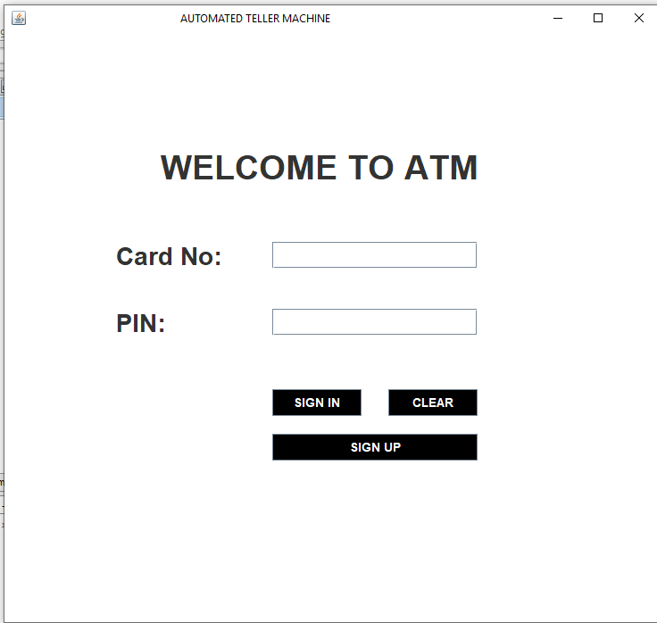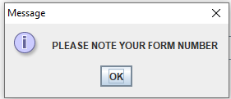
SIGNUP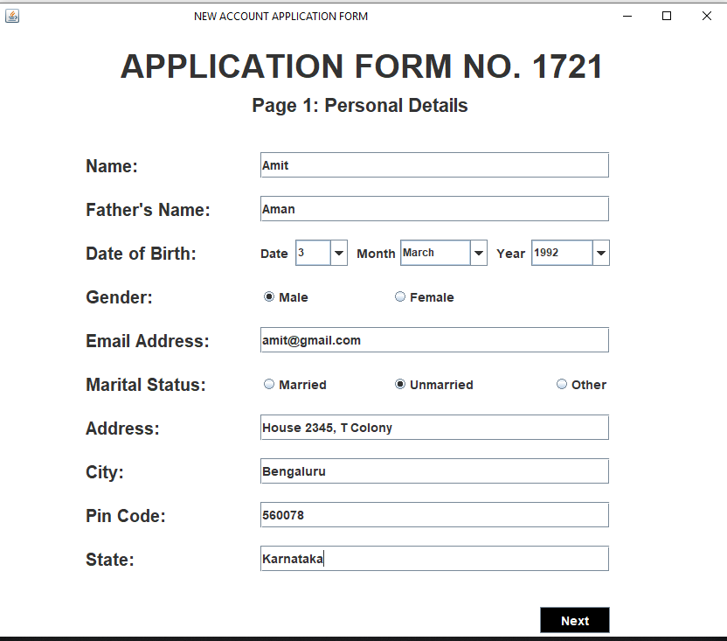
SIGNUP2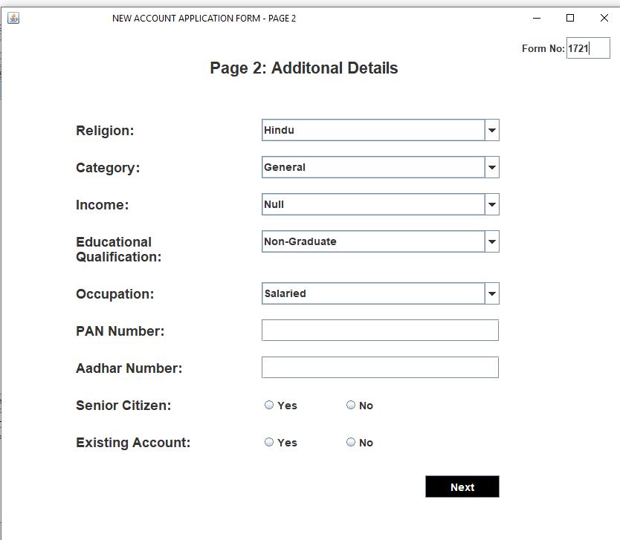
SIGNUP3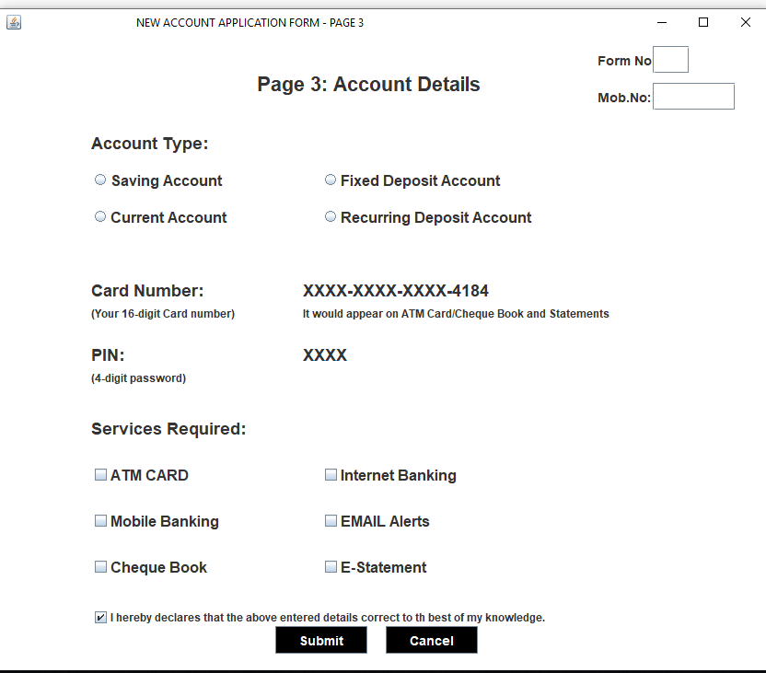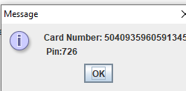
DEPOSIT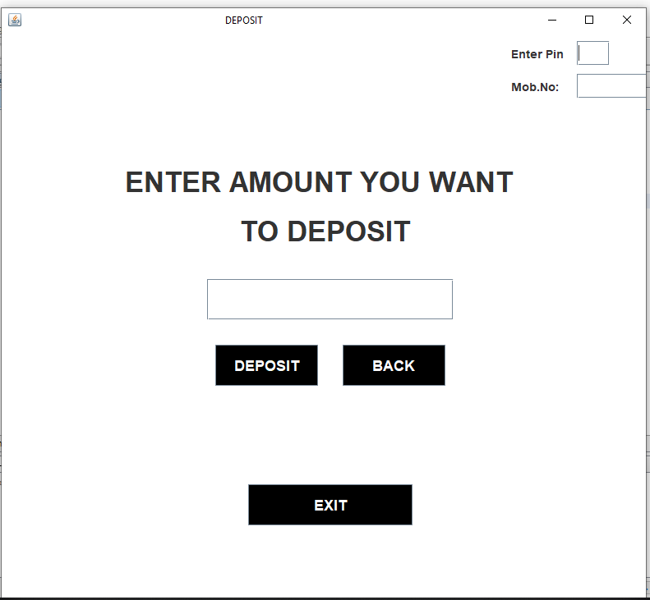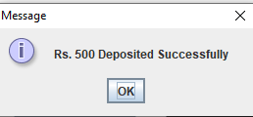
TRANSACTIONS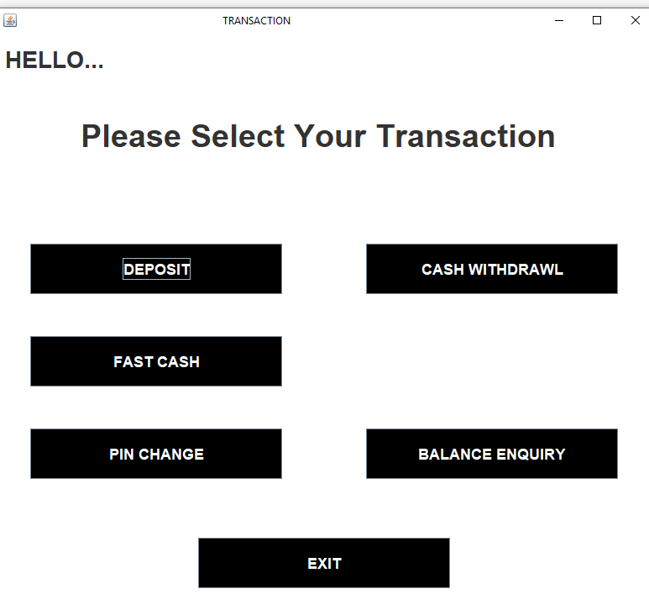FASTCASH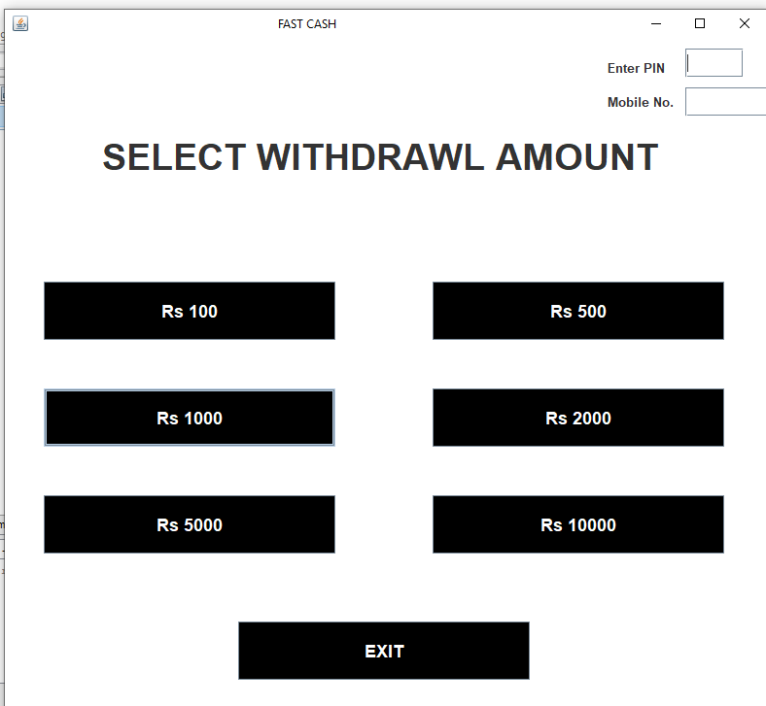
WITHDRAW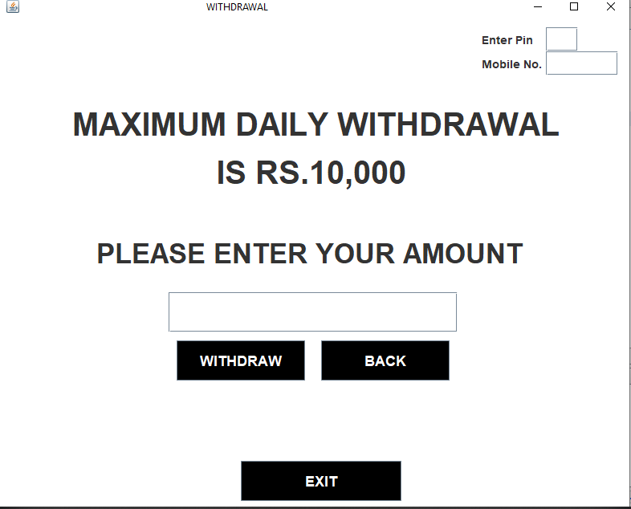
PIN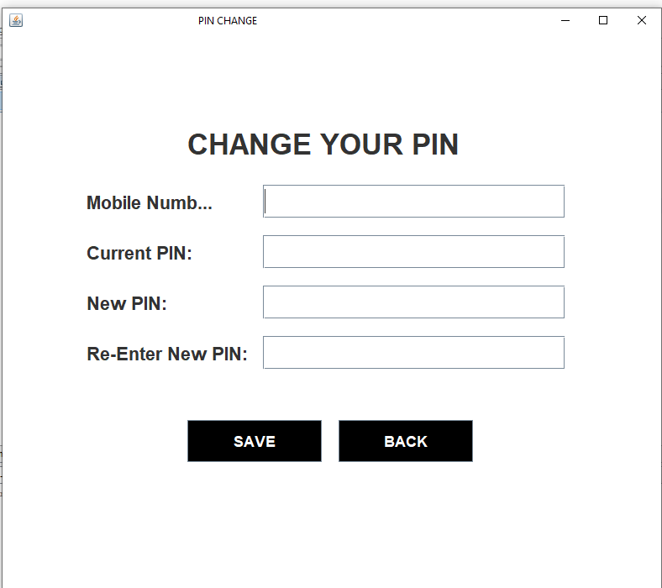
BALANCE 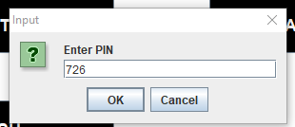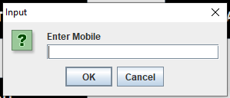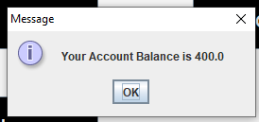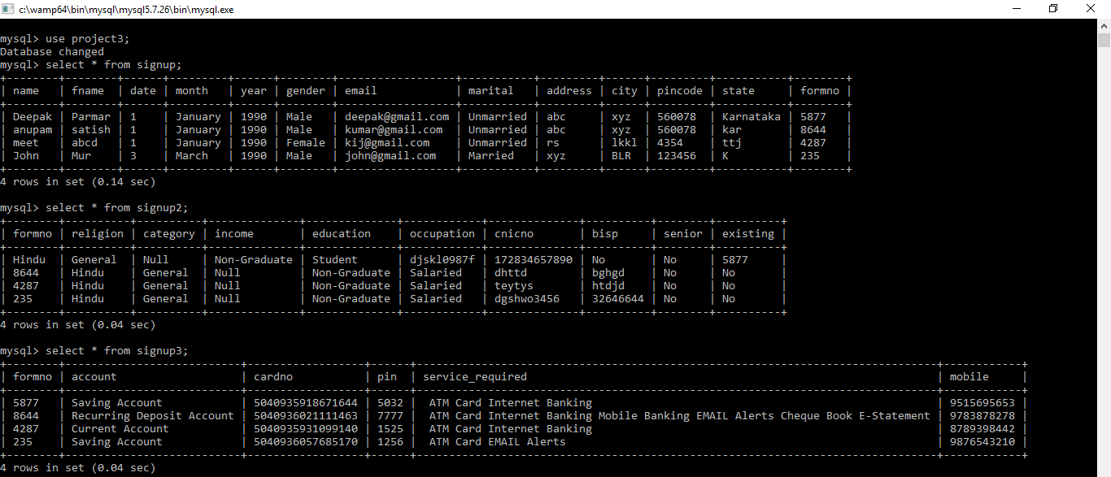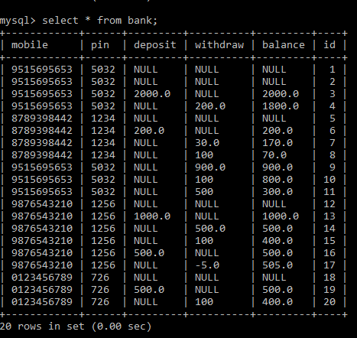

CONCLUSION

Our team believes that the design yields a simple, easy to use system. The cardholder is prompted through the system at every step of the way with sufficient error checking to prevent invalid input.
This system meets all of the assignment design criteria. It can:
- Login using Card Number and PIN
- New User Signup and generation of new Card number and PIN
- Cash Deposit using PIN
- Cash Withdraw using PIN
- Fast Cash using PIN
- PIN Change
- View account balance
Additionally, we have exceeded the minimum assignment requirements by adding and/or implementing the following:
- Email validation.
- Using mobile number and pin together.

REFERENCES
- https://docs.oracle.com/javase/tutorial/jdbc/basics/sqlexception.htmls
- http://www.codeforinterview.tk/2019/05/bank-management-system.html
- The Complete Reference J2ME
- The Complete Reference Java

